Changes in the Seoul Metropolitan Area Urban Heat Environment with Residential Redevelopment

Je-Woo Hong and Jinkyu Hong*

Ecosystem-Atmosphere Process Laboratory, Department of Atmospheric Sciences, Yonsei University, Yonsei-ro 50, Seodaemun-gu, Seoul 03722, Korea

*Corresponding Author: Jinkyu Hong, Ecosystem-Atmosphere Process Laboratory, Department of Atmospheric Sciences, Yonsei University, Yonsei-ro 50, Seodaemun-gu, Seoul 03722, Korea.

E-mail: jhong@yonsei.ac.kr

**Abstract**

Since the industrial revolution, the geographical extent of cities has increased around the world. In particular, following three decades of rapid regional economic growth, many Asian megacities have emerged and continue to expand resulting in inevitable short-term urban redevelopment. However, in this region the microclimatic impacts of urban redevelopment have not been extensively investigated using long-term in-situ observations. In this study, changes in surface sensible heat exchange, heat storage, and anthropogenic heat emissions due to urban residential redevelopment were quantified and analyzed based on a three-year micrometeorological record from the Seoul metropolitan area. The results show that following urban redevelopment of compact high-rise residential buildings: 1) the daily minimum air temperature near the ground surface increased by ~0.6 K; 2) the ratio between surface sensible heat and net radiation increased by ~9% (summer) to 31% (winter), anthropogenic heat emissions increased by 7.6 W m-2 (summer) to 23.6 W m-2 (spring), and daily maximum heat storage ranged from 35.1 W m-2 (spring) to 54.5 W m-2 (summer), and; 3) there was a transition of local circulation with changes in the surface properties of heat sources and roughness.

1. **Introduction**

Since pre-industrial times, humans have exerted a major influence on the climate system (Intergovernmental Panel on Climate Change 2013; Monastersky 2015). To mitigate or adapt to human-induced climate change, it is important to assess anthropogenic impacts on the environment. Urban environments are strongly linked to anthropogenic activities, because: (1) more than half of the world’s population lives in urban areas (United Nations 2014); (2) production, consumption, and waste disposal are concentrated in urban areas; and (3) land use and land cover changes (LULC) are mainly driven by urban environments and their socioeconomic footprint zones (Grimm et al. 2008; Trusilova and Churkina 2008). Particularly, urbanization and its related LULC significantly impact on the heat environment by changing the regional and global weather and climate, which regulate air temperature, humidity, atmospheric stability, and precipitation in the planetary boundary layer. Since the pioneering studies on the urban heat island (UHI; Howard 1833; Balchin and Pye 1947), many studies have quantified the magnitude of UHI (Arnfield 2003). However, the monitoring of turbulent heat exchange in cities has only recently become a research focus.

The micrometeorological method, a useful tool for better understanding microclimates, enables us to quantify exchanges of momentum, energy, and mass between the Earth’s surface and atmosphere (Baldocchi et al. 2001). Since the first sensible heat flux measurements were conducted in Vancouver, Canada (Yap and Oke 1974), micrometeorological measurements of turbulent energy exchange at the city-atmosphere interface have been applied extensively (e.g., Grimmond and Oke 1995; Christen and Vogt 2004; Grimmond et al. 2004; Lemonsu et al. 2004; Moriwaki and Kanda 2004; Feigenwinter and Vogt 2005; Offerle et al. 2005; Coutts et al. 2007; Masson et al. 2008; Vesala et al. 2008; Balogun et al. 2009; Frey et al. 2011; Ramamurthy and Pardyjak 2011; Velasco et al. 2011; Bergeron and Strachan 2012; Frey and Parlow 2012; Liu et al. 2012; Goldbach and Kuttler 2013; Zieliński et al. 2013; Chow et al. 2014a; Ward et al. 2014).

Compared with flux studies in the natural ecosystem, long-term measurements in cities are limited. Furthermore, most urban flux sites are located in Europe and America, while the urban energy budgets of Africa, Asia, and Oceania have not been extensively investigated (Moriwaki and Kanda 2004; Offerle et al. 2006; Grimmond and Christen 2012; Liu et al. 2012; Ward et al. 2013; Kotthaus and Grimmond, 2014). Offerle et al. (2005) and Frey et al. (2011) reported on the urban surface energy balance in Ouagadougou (Burkina Faso) and Cairo (Egypt). Coutts et al. (2007) observed urban energy flux at three different levels of urbanized sites (i.e., high, medium, and low) in Melbourne, Australia. Liu et al. (2012) and Moriwaki and Kanda (2004) reported on urban surface flux measurements in Beijing, China, under semi-arid continental climate conditions, and in Tokyo, Japan, over a suburban residential area.

In the Asian region, many megacities have emerged in the last three decades and have continued to expand with rapid regional economic growth. This rapid urban growth is inevitably accompanied by short-term urban redevelopment and the subsequent reconsolidation of urbanization. During urban redevelopment, land cover information and geomorphic structures show dramatic changes and alter building structure parameters (e.g., horizontal building fraction, building height, sky view factor) and aerodynamic parameters (e.g., zero plane displacement and roughness length), thereby modulating the heat environment substantially. However, the microclimatic impacts of urban redevelopment on the urban surface energy balance have not been extensively investigated using long-term in-situ observations at a single Asian locality.

This study focused on the unique features of urban structures in the Seoul metropolitan area, Korea, one of the Asian megacities. Over the past 50 years, and in response to rapid economic growth, Korean urban development policy has focused on the increasing demand for residential stock and a commuter infrastructure (Kim and Han 2012). As a result of rapid economic and social change, today 91% of the total population lives in urban areas, which cover just 16.6% of the total land area (Ministry of Land, Infrastructure and Transport of Korea 2013). Furthermore, more than half of the total population is concentrated in the Seoul metropolitan area, which has a 30 km radius and represents just 11.8% of the total land area. Consequently, compact (building surface fraction ~50%) and high-rise (tens of stories, ~25 m) environmental conditions are not uncommon in Seoul, giving the city a unique urban structure and function, as compared with cities in western countries. Unlike European and American cities, which have relatively lower building density and long life cycle (e.g., > 50-yr for buildings in Europe), a high-density and a short life cycle (about 30-yr) of buildings is characteristic. Since ‘the special act on the accelerating urban renewal’ was established in 2005, and along with socio-economic development and increasing concern over environmental issues, a ‘New Town’ plan has been legislated as a housing redevelopment policy in Seoul and its satellite cities (Lee and Lee 2009). Since 2002, 35 districts, covering ~27.22 km2 of redevelopment and large-scale apartment complex construction, have been completed. Limited studies have investigated urban climate and its impacts on local air temperature in Seoul (e.g., Eum et al. 2011; Yi et al. 2012a and 2012b; Eum et al. 2013). However, the lack of long-term in-situ measurements of surface heat fluxes hinder our understanding of the interplay between urban redevelopment and environmental change (Lowry 1977).

The present study reports on changes in the heat environment due to urban residential redevelopment by analyzing a 3-year micrometeorological record observed in the Seoul metropolitan area, a temporal span that both pre- and post-dates the most recent urban redevelopment, using high-resolution airborne Light Detection And Ranging (LiDAR) data. We highlight the effects of residential redevelopment on sensible heat flux, heat storage, and anthropogenic heat emissions in compact high-rise residential areas that have been recently redeveloped from low-rise residential areas.

1. **Materials and Methods**
2. *Urban Energy Balance*

The urban surface energy balance can be expressed as:

Q* + QF = QH + QE + ΔQS + ΔQA (1)

where downward net radiation (Q*) and emitted anthropogenic heat (QF) are partitioned into sensible heat flux (QH), latent heat flux (QE), stored within the urban volume (ΔQS), and horizontal advection with the regional or local circulation (ΔQA; Oke 1988). For the radiative fluxes and QF, the downward direction (into the surface volume) has a positive sign, while QH andQE show the opposite convention. Q* is balanced with downward (↓) and upward (↑) short- (K) and long-wave (L) radiation, as follows:

Q* = K↓ - K↑ + L↓ - L↑ (2)

where K and L are short- and long-wave radiation, respectively, and downward and upward arrows indicate downward and upward components of radiative fluxes. QH and Q* were directly measured over the EunPyeong New Town area. ΔQA was negligible because of the similar building structures and functions within a tower footprint, and QF was included in the measured QH. It is commonly known that the QE is relatively smaller than QH in urban environments. Our recent eddy covariance flux measurement at the site revealed that the seasonal Bowen ratio (=QH/QE) ranged from 1.3 (summer) to 5.1 (winter) at EunPyeong New Town, implying that QE is about 20% (winter) to 80% (summer) of QH approximately.

*b. Site Description*

Data were collected in the EunPyeong New Town district, situated in northwestern Seoul (37.64oN, 126.9oW; Fig. 1a). The flux measurement tower was located near an apartment complex consisting of multiple identical buildings extending 2 km from the tower. Due to the New Town construction, the total population dramatically increased from 3,647 (317 people per km2) in June 2008 to 49,524 (4,299 people per km2) in December 2012. Based on the Stewart and Oke (2012) classification scheme, the local climate zone (LCZ) changed from compact low-rise (until 2005), via compact mid-rise with bare-soil (2006–2009; Fig. 1b), to compact high-rise after the redevelopment (after January 2010; Fig. 1c). During construction, the district included apartment substructures and bare-soil. All green areas (i.e., garden and street trees) were removed. After completion, the LULC was categorized as a large-scale apartment complex with gardens and street trees. During the initial part of the measurement period, building heights were ~50% of their final height on completion of the redevelopment, which occurred in November 2009, a year before the end of the measurement period. With the flux measurement tower at the center, the residential-area forms a relatively flat (< 2o southwestwards slope) area, with a hilly region to the north.

(Figure 1)

Mean annual air temperature and precipitation from 2008 to 2011 were 12.4 oC and 1,681 mm, respectively (Table 1). Across the study period, air temperature and precipitation showed large annual variations reflecting the monsoon-controlled climate (Fig. 2). Generally in Asia, half of the annual precipitation is concentrated during the summer monsoon (June–August), which has ecological impacts on the region (Hong and Kim 2011; Hong et al. 2014). Annual precipitation in 2009, 2010, and 2011 was significantly above the norm; in particular, monthly precipitation in July 2011 was 1,079.5 mm. This brought about a decrease in net radiation (Q*) during the mid-summer of 2011. Wind climatology observed at the Seoul synoptic station also showed similar seasonal changes (not shown here).

(Table 1)

(Figure 2)

*c. Measurement System and Data Processing*

The 10 m high flux measurement lattice tower was built on the rooftop of a 20 m high building (i.e., 30 m from ground). A three-dimensional sonic anemometer (CSAT3, Campbell Scientific, USA) and a net radiometer (CNR1, Kipp & Zonen, Netherlands) were installed at 10 m (top of the tower) above the rooftop. All wind components (u, v, w) and sonic temperatures (TS) were measured at a 10 Hz sampling rate, and 10-minute averages of downward and upward short- and long-wave radiation (K↓, K↑, L↓, and L↑) were collected using a data logger (CR3000, Campbell Scientific, USA).

Surface sensible heat flux (QH) was directly measured by a three-dimensional sonic anemometer (CSAT3, Campbell Scientific, USA), using a 30-minute averaging period, and a double rotation (McMillen, 1988; Kaimal and Finnigan, 1994). Surface air pressure and relative humidity data observed at the Seoul synoptic weather observation station (~7.5 km away from the flux tower; triangle in Fig. 1) were used for converting the kinematic sensible heat flux ($\overline{w'{∙T}_{s}'}$) to the QH (where the overbar and primes denote the time averaging and perturbations from the mean, respectively). Air density multiplied by heat capacity (ρ·CP) ranged from 1,150 J K-1 m-3 during the hot and humid summer, to 1,350 J K-1 m-3 during the cold and dry winter season, where ρ is the air density (kg m-3), and CP is the specific heat of air (J K-1 kg-1; Fig. 2d). Storage heat flux (ΔQS) was estimated from the hysteresis between Q* and QH after the urban redevelopment (Appendix A).

The measurement period spanned 1,295 days (21 November 2008–08 June 2012); however 424 days of data were lost, mainly comprising 11 months (298 days) from the 03 February 2010 when the tower was moved due to the redevelopment. As a result, the total operational period (871 days) included 404 days during the redevelopment (21 November 2008–02 February 2010), and 467 days after the redevelopment was completed (28 November 2010–09 June 2012).

It is probable that our measurement height of 1.5 times the mean building height may not have measured neighborhood-scale turbulent fluxes in the inertial sub-layer, and turbulent fluxes were affected by the wake from the building and tower structure (Oke, 2006). Our analyses showed that: 1) the power spectra of wind components and sonic temperatures had the theoretical slopes in the inertial subrange without any evidence of wake during the year (Hong, 2014); 2) the wind profile under near neutral conditions (|z/L| < 0.01 where L is the Obukhov length) did not significantly deviate from the Monin-Obukhov similarity prediction; 3) the range of rotation angle was similar to that of other studies (Nemitz et al., 2002; Vesala et al. 2008) in the inertial sub-layer, and 4) the deviation of integral turbulence characteristics from the Monin-Obukhov similarity was also small (not shown here). These findings indicate that roughness sub-layer issues do not impact on our interpretation and conclusions.

*d. Flux Footprint and Airborne LiDAR Image Analysis*

Flux footprint climatology is essential for the interpretation of surface flux measurements and satellite data (Schmid and Oke 1990; Schmid 2002; Shim et al. 2014). To quantify the spatial representativeness of the source areas of the observed surface fluxes, the turbulent flux footprint and radiative flux footprint were calculated following Hsieh et al. (2000) and Lambert’s cosine law (Schmid 1997), respectively.

In order to accurately model and interpret the tower footprint, aerodynamic parameters such as zero-plane displacement height and roughness length, land cover classification, and the sky view factor were required. To quantify these, high-resolution (1 m horizontal, and 1 cm vertical scale) airborne LiDAR images within the tower footprint were analyzed (Fig. 3a). The sky view factor (ψ), the ratio of the sky view to the entire hemisphere, is an important parameter in urban studies because it regulates the effective albedo and long-wave radiation cooling (Oke 1982). Until the early 2000s, several graphic methods for estimating ψ used photographs (Blennow 1995; Grimmond et al. 2001). However, more recently, the increasing accessibility of airborne LiDAR data has enabled us to apply more reliable numerical methods (Gál et al. 2009; Lindberg and Grimmond 2011) and simple parameterization methods using just a few lines of building structural data (e.g., the mean building height ($\overline{z_{H}}$), plan areal fraction (λP), frontal area index (λF), and the height to width ratio between buildings and roads; Kusaka and Kimura 2004). In this study, ψ of each grid point was estimated in 10o intervals within 200 m from the flux tower using several parameterization methods (Table 2), as described in detail by Grimmond and Oke (1999b). All parameters (, λP, λF, z0, and zd) were estimated in 45o intervals.

(Figure 3)

(Table 2)

*e. Urban Heat Island Intensity*

To investigate the effect of residential development on UHI intensity at the EunPyeong site, air temperature differences at the urban canopy level between EunPyeong and the Seoul synoptic weather observation station were estimated using the moisture mixing ratio (q) from the Seoul synoptic observation station and the simple equation:

TEP = (TS + 273.15)/(1+0.000321·q) (3)

The sonic temperature (TS) was converted to air temperature (TEP in Kelvin). According to the local climate zone classification by Stewart and Oke (2012), the EunPyeong site is classed as compact high-rise with forest (type 1A), while the Seoul synoptic observations were made in a compact mid-rise with scattered trees (type 2B). In previous studies, both the thermal differentiation and differences in diurnal temperature range between these two types were shown to be negligible, and the air temperatures of Seoul synoptic observations (TSE) had almost the same magnitude as the mean of 29 automatic weather stations in Seoul (Hong et al. 2013). Therefore, the thermal differences (TEP - TSE) between the EunPyeong and Seoul synoptic observation station are a measure of the effect of residential development on changing UHI intensity.

1. **Results and Discussion**

*a. Surface Roughness*

The mean sky view factor (ψ) for pixels at all levels (including roof and ground levels) was 0.5 (Fig. 3b). This value is similar to the values of previous studies of dense residential areas in Szegen, Hungary (Gál et al. 2009), and central London, England (Lindberg and Grimmond 2011). Most roof and forested areas had large sky view factors (~ 1; bright color in Fig. 3b). Importantly, the ψ of the street level under the buildings was below 0.2 (dark color), which is typical of high-rise urban areas. This smaller ψ implies significant changes in the urban heat environment because: 1) during the daytime, more solar radiation is trapped within the building area and as a result the available energy in the surface energy budget tends to increase; and 2) outgoing long-wave radiation is reduced and as a result UHI is intensified during the nighttime.

Based on the high-resolution LiDAR data, morphology information was estimated in 45˚ intervals (Table 3). Mean horizontal building fraction (λP = AP/AT) was estimated to be ~0.21 (ranging between 0.09 towards NNW, and 0.33 towards SSE) and mean build-height ($\overline{z_{H}}$) was ~21.5 m (ranging between 16.1 m towards NNE, and 29.6 m towards WNW). Zero-plane displacement (zd) and roughness length (z0) around the tower, which are important aerodynamic parameters for surface turbulent exchanges of energy and mass, were ~10.2 m (ranging between 5.7 m towards NNW, and 14.0 m towards WNW) and ~1.8 m (ranging between 0.7 m towards NNW, and 2.8 m towards WNW), respectively. These represented estimated mean values using the formulae in Table 2.

(Table 3)

These changes in surface roughness made a noticeable alteration to the location of peak contribution of turbulent flux. After the residential redevelopment was completed, the increases in zd and z0 resulted in peak locations of turbulent flux that were closer to the flux tower (Fig. 4b and c). During construction, peak locations at ~200 m were common, but after the redevelopment most peak locations were at distances distributed within 200 m. Furthermore, atmospheric instability increased due to increased sensible heat flux, which produced smaller footprints after the redevelopment. It was also noticeable that local flow circulation around the tower changed with the redevelopment (Fig. 4); however, these changes in turbulent flux footprints did not significantly impact on the measurement results because building structures, building functions, and land cover were relatively homogeneous and flat within the flux footprint.

During the construction, artificial heat release was negligible and the direction of local flow was north–south (night–day) because the redevelopment was completed in a short period of time and residents moved in soon after the redevelopment. After the redevelopment, the flow turned clockwise to become northeast–west. Considering that the synoptic conditions of study period were quite similar (i.e., the wind-rose from the synoptic observatory was similar; not shown here), we speculate that this change was mainly associated with the newly formed daytime heat source position, the apartment complex. The prevailing wind direction during the daytime changed from the south to the west. At these conditions, the flux footprint was dominated by impervious surfaces (65.4%), and the composition of buildings (24.0%), roads (28.7%), and pavements (12.7%).

Figure 4a shows the source areas of radiative fluxes. The 70% and 95% radiative flux footprint corresponded to ~46 m and 131 m of radius from the flux tower, respectively. These areas include apartments and roads covered by asphalt to the south, and a playground (mainly bare-soil) and apartment wall to the north; thus, well representing the building and road areas.

(Figure 4)

*b. Urban Heat Island Intensity*

The mean diurnal patterns of temperature difference (TEP - TSE) between EunPyeong and the Seoul synoptic observation station were compared after the redevelopment (Fig. 5). Data from March 2009 (during the construction), and August–September 2011 (after the redevelopment) were excluded from the analysis, because the number of data days were < 15 days in a month (3–5, 3–5, and 10–11 days, respectively). During the daytime (08:00–13:00), the EunPyeong site showed almost the same air temperatures as the Seoul synoptic observation station, but it was colder during the nighttime and early morning (1800–0800). The cold nighttime events, which occurred consistently throughout the study period, are inferred to be related to the local circulation structure, which is controlled by the mountain-valley breeze around the EunPyeong site. Notably, after the redevelopment was completed, seasonal differences in the thermal difference increased (Fig. 5a and b). Furthermore, the UHI intensified by ~1 K during the nighttime (Fig. 5c). In contrast, the lack of change during the daytime reveals that the effects of residential development on UHI are only valid through long-wave cooling processes.

(Figure 5)

*c. Changes in the Heat Environment*

1. SENSIBLE HEAT FLUX

The data show that QH has increased since the development of the high-rise residential buildings (Fig. 2b and Fig. 6). During construction, the daily maximum QH was ~150 W m-2, but after the development QH values of > 200 W m-2 were frequent. This enhancement in QH cannot be explained by different climate conditions before and after the development because the ratio of sensible heat flux to net radiation (QH/Q*) also increased (Table 4; Fig. 7). Except for the abnormally rainy summer (July 2011), daytime QH/Q* varied seasonally, increasing from 9% in the summer, to 31% in the winter. The daily increases in QH and QH/Q* during the winter were larger than those during the summer. The causes of the observed increases in sensible heat flux include the favorable conditions from decreased nocturnal radiative cooling and increased anthropogenic heat emissions from fossil fuel combustion (gasoline for traffic and natural gas for residences), electricity consumption, and human metabolism (residences and public facilities) due to the significantly increased population density. Notably, sensible heat flux increased significantly in the winter after the redevelopment was completed, possibly because of local heating effects in cold weather. Inventory data analysis in the Seoul metropolitan area corroborates that anthropogenic heat emissions are concentrated in winter (Lee et al. 2009; Lee et al. 2015). Our observations also show that the increases in QH/Q* after the redevelopment were greatest in winter, a relatively cold and dry season. Based on daily (24-hour) averaging, QH/Q* tripled from 0.43 to 1.42 (Table 4). During summer, a warm and humid season, the increment was smallest (0.27–0.36).

(Figure 6)

(Figure 7)

(Table 4)

Increased urbanization provides favorable conditions for drier urban surfaces by increasing the impervious area. Under these conditions, infiltration and evaporation decreased by lowering soil water content, directly impacting on hydrologic process and surface energy balance patterns. During construction, QH/Q* approached an equilibrium value of 0.25 within 4 hours of rainfall events; however, QH/Q* converged to 0.45 and the convergence time to the equilibrium was 12 hours after the redevelopment (Fig. 8). Delayed equilibrium (~12–18 hours) has been reported in the dense city center of London (Kotthaus and Grimmond 2014) and can be interpreted to reflect decreased ψ after development. During the construction, trees and grass in the street were rare and building heights were relatively smaller than in the completed redevelopment. Such changes in the structure of buildings and streets decreased ψ, resulting in delayed latent heat fluxes due to the broadening surface shadow area after redevelopment. From the perspective of moisture storage, our findings indicate that urban green areas play an important role in partitioning surface energy.

(Figure 8)

1. HEAT STORAGE AND ANTHROPOGENIC HEAT EMISSIONS

With the increased sensible heat flux after the redevelopment, the time of peak QH became delayed (Fig. 6), changing from ~12:00 during the construction, to ~14:00, indicating an increase in ΔQS. This time delay was related to the hysteresis of diurnal evolution of sensible heat flux and net radiation (Fig. 9). The hysteresis indicates that in the early morning almost the whole of Q* was partitioned to ΔQS by increasing the temperature of buildings and roads (i.e., storing heat). In contrast, during the afternoon, most of Q* was partitioned to QH and the stored energy was released. This distinct hysteresis pattern after the redevelopment is consistent with the results of previous studies (e.g., Grimmond and Oke 1999a; Rigo and Parlow 2006; Velasco et al. 2011; Ramamurthy et al. 2014).

(Figure 9)

At the EunPyeong New Town site, the counterclockwise hysteresis pattern between Q* and QH was observed every month after the redevelopment (Fig. 9). When ΔQS was negligible, sensible heat flux had a linear relationship with net radiation (i.e., no hysteresis between Q* and QH); therefore, heat storage was estimated from the residual of the observed hysteresis from this hypothetical linear relationship when there is no heat storage (Appendix A; Table 4). This approach is reasonable because: 1) QE is mainly emitted by natural land cover, and as such QE has no real dependence on ΔQS; 2) the sum of seasonal and diurnal heat storage is nearly zero; and 3) most of QF came out as QH (direct heat from chimneys or vehicles), Q* (radiative forcing), and ΔQS (heat storage within the urban canopy), which had already been considered. The estimated mean daily (24-hour) ΔQS of each season ranged from -0.8 W m-2 in the summer, to 7.5 W m-2 in the autumn (Table 4).

The maximum ΔQS (i.e., the maximum distance between the hysteresis curve and the virtual linear line) was 37.9 W m-2, 35.1 W m-2, 54.5 W m-2, and 44.3 W m-2 for winter, spring, summer, and autumn, respectively (positive in the morning and negative in the afternoon), indicating the importance of ΔQS on the urban surface energy balance. This magnitude is comparable with Chicago, United States, in June–August 1995, where summertime ΔQS was 33.3 W m-2 (daytime) and the 24-hour QH:Q* ratio was 0.51 (Grimmond and Oke 1999a), with ΔQS measured by the residual method: ΔQS = Q* -QE – QH. Among the seven cities investigated by Grimmond and Oke (1999a), only Chicago had a high dense urban site, with a ratio of the total surface area to total plan area of 1.71. The ΔQS of Vancouver and Sacramento were similar (23.3 W m-2 and 37.7 W m-2, respectively), but Arcadia, which had no rainfall, was 63.1 W m-2 in 1994 and 54.3 W m-2 in 1993. Vancouver ‘Sunset’, Sacramento, and Arcadia (Los Angeles), had similar horizontal land cover (40–60% of building and roads), but they mainly comprised low-rise (1–2 story) houses and had climate conditions significantly drier than those in Seoul.

Emitted anthropogenic heat could be partitioned into sensible heat flux and latent heat flux (Sailor, 2011; Chow et al., 2014b). However, around the flux tower, there was no cooling tower, and latent heat from combustion was also small enough to ignore. Therefore, the mean daily (24-hour) QF of each season was estimated by comparing QH/Q*, and by assuming that QF was negligible during the last stage of the redevelopment when the building construction was almost complete but residents had not yet moved in (Table 4):

$\overline{Q_{F}}=\overline{Q^{*}}× \left\{{\left(Q_{H}/Q^{*}\right)}_{after construction}-{\left(Q_{H}/Q^{*}\right)}_{during construction}\right\}$ (4)

Our estimation of mean daily QF, which was the product of mean Q* and changes in the slope of QH/Q*, showed that the seasonal variation range was 7.6 to 23.6 W m-2, occurring during the summer and spring, respectively. A previous inventory-based study around the site reported about ~10–15 W m-2 of annual mean QF (Lee et al. 2009; Lee et al. 2015), which is similar to the annual mean from our estimation. Our estimation showed relatively larger QF in winter and spring seasons and future investigation into the temporal variation of QF should be done from a perspective of footprint mismatch between turbulent fluxes and radiometer, energy use efficiency, use of electricity, traffic condition, and climate.

1. **Summary and Conclusions**

Urban redevelopment is a complex socio-ecological challenge for sustainability and co-prosperity in Asian megacities. To achieve urban sustainability, it is necessary to evaluate changes in microclimate due to urban redevelopment and their effect on the socio-ecological system. Such evaluations require high quality long-term monitoring data of heat environments. Micrometeorological measurement methods are useful for quantifying the exchanges of momentum, energy, and mass between the urban surface and the atmosphere. This study, which aimed to understand the effects of residential redevelopment on the microclimatic heat environment, is the first report on multi-year (21 November 2008–08 June 2012) eddy-covariance measurements at the EunPyeong New Town district of the Seoul metropolitan area, Korea, where high-rise residential redevelopment continued throughout the study period.

After the redevelopment, the local climate zone changed from compact low-rise to compact high-rise and the aerodynamic parameters changed substantially as buildings were constructed. Based on airborne LiDAR data, the λP, , zd, z0, and ψ within the flux footprints were 0.21, 21.5 m, 10.2 m, 1.8 m, and 0.5, respectively. During the redevelopment, the dominant land fraction type was replaced by impervious surfaces consisting of buildings, roads, and pavements. Consequently, QH increased and a distinct hysteresis pattern between Q* and QH was delineated. The main reasons for this QH increment are interpreted to be the dry conditions over the impervious surfaces, as well as ΔQS. In the morning, a large proportion of Q* was partitioned into the ΔQS and stored in buildings and roads. This accumulated ΔQS was released in the afternoons and the ratio between QH and Q* became larger than unity. The estimated mean ΔQS ranged from -7.5 W m-2 in autumn to 0.8 W m-2 in summer. In addition to morphological variations, QF is another potential factor relating to increased surface heat release into the atmosphere. During the redevelopment, the population density increased by more than an order of magnitude. Changes in QH/Q* after the redevelopment revealed QF magnitudes of 7.6–23.6 W m-2, which is similar to previous research based on an inventory study. Such surface thermal conditions intensified the urban heat island, resulting in an ~0.6 K incremental increase during the nighttime, as compared with the rural environment.

**Acknowledgements**

This study was supported by the Long-term Ecological Study and Monitoring of Forest Ecosystem Project of the Korea Forest Research Institute, the Korean Meteorological Administration Research and Development Program (KMIPA2015-2063). The first author was supported by the Global Ph.D. Fellowship Program (NRF-2015H1A2A1030932). We thank the anonymous reviewers and editor for valuable comments on the manuscript.

APPENDIX A

Derivation of heat storage (ΔQS) from the hysteresis curve of QH

Heat storage inside an urban canopy can be quantified by calculating the difference between the measured sensible heat flux and the virtual linear relationship between Q* and QH when there is no heat storage (Fig. A1):

${∆Q}_{S}= \hat{Q_{H}}-Q_{H}$ (A1)

The virtual linear equation should pass the two points (Q*1, QH1) and (Q*2, QH2), giving:

$\begin{matrix}\hat{Q_{H}}=c_{1}∙Q^{*}+c_{2} \\ = \frac{1}{{Q^{*}}_{2}-{Q^{*}}_{1}}\left[\left(Q_{H2}-Q_{H1}\right)Q^{*}+\left(Q_{H1}{Q^{*}}_{2}-Q_{H2}{Q^{*}}_{1}\right)\right]\end{matrix}$ (A2)

(Figure A1)

**References**

Arnfield, A. J., 2003: Two decades of urban climate research: a review of turbulence, exchanges of energy and water, and the urban heat island. *Int. J.* *Climatol.,***23**, 1-26.

Balchin, W. G. V., and N. Pye, 1947: A micro climatological investigation of bath and the surrounding district. *Quart. J. Roy. Meteor. Soc.*, **73**, 297-323.

Baldocchi, D., and Coauthors, 2001: FLUXNET: A new tool to study the temporal and spatial variability of ecosystem-scale carbon dioxide, water vapor, and energy flux densities. *Bull. Amer. Meteor. Soc.*, **82**, 2415-2434.

Balogun, A. A., J. O. Adegoke, S. Vezhapparambu, M. Mauder, J. P. McFadden, and K. Gallo, 2009: Surface energy balance measurements above an exurban residential neighbourhood of Kansas City, Missouri. *Bound.-Layer Meteor.*, **133**, 299-321.

Bergeron, O., and I. B. Strachan, 2011: CO2 sources and sinks in urban and suburban areas of a northern mid-latitude city. *Atmos. Environ.*, **45**, 1564-1573.

Blennow, K., 1995: Sky view factors from high-resolution scanned fish-eye lens photographic negatives. *J. Atmos. Oceanic Technol.*, **12**, 1357-1362.

Chow, W. T., T. J. Volo, E. R. Vivoni, G. D. Jenerette, and B. L. Ruddell, 2014a: Seasonal dynamics of a suburban energy balance in Phoenix, Arizona. *Int. J.* *Climatol.*, **34**, 3863-3880.

Chow, W. T., F. Salamanca, M. Georgescu, A. Mahalov, J. M. Milne, and B. L. Ruddell, 2014b: A multi-method and multi-scale approach for estimating city-wide anthropogenic heat fluxes. *Atmos. Environ.*, **99**, 64-76.

Christen, A., and R. Vogt, 2004: Energy and radiation balance of a central European city. *Int. J. Climatol.*, **24**, 1395-1421.

Counihan, J. 1971: Wind tunnel determination of the roughness length as a function of the fetch and the roughness density of three-dimensional roughness elements. *Atmos. Environ.,* **5**, 637-642.

Coutts, A. M., J. Beringer, and N. J. Tapper, 2007: Impact of increasing urban density on local climate: spatial and temporal variations in the surface energy balance in Melbourne, Australia. *J. Appl. Meteor.* *Climatol.,* **46**, 477-493.

Eum, J-H., D. Scherer, U. Fehrenbach, and J-H. Woo, 2011: Development of an urban landcover classification scheme suitable for representing climatic conditions in a densely built-up Asian megacity. *Landscape Urban Plan.*, **103**, 362-371.

Eum, J-H., D. Scherer, U. Fehrenbach, J. Köppel, and J-H. Woo, 2013: Integrating urban climate into urban master plans using spatially distributed information-the Seoul example. *Land Use Policy*, **34**, 223-232.

Feigenwinter, C., and R. Vogt, 2005: Detection and analysis of coherent structures in urban turbulence. *Theor. Appl. Meteor.*, **81**, 219-230.

Frey, C. M., E. Parlow, R. Vogt, M. Harhash, and M. M. Abdel Wahab, 2011: Flux measurements in Cairo. part 1: in situ measurements and their applicability for comparison with satellite data. *Int. J.* *Climatol.,* **31**, 218-231.

Frey, C. M., and E. Parlow, 2012: Flux measurements in Cairo. Part 2: On the determination of the spatial radiation and energy balance using ASTER satellite data. *Remote Sens.*, **4(9)**, 2635-2660.

Gál, T., F. Lindberg, and J. Unger, 2009: Computing continuous sky view factors using 3D urban raster and vector databases: comparison and application to urban climate. *Theo. Appl.* *Climatol.,* **95**, 111-123.

Garratt, J. R., 1992: The atmospheric boundary layer. *Cambridge University Press*, 316 pp.

Goldbach, A., and W. Kuttler, 2013: Quantification of turbulent heat fluxes for adaptation strategies within urban planning. *Int. J.* *Climatol.,* **33**, 143-159.

Grimm, N. B., S. H. Faeth, N. E. Golubiewski, C. L. Redman, J. Wu, X. Bai, and J. M. Briggs, 2008: Global change and the ecology of cities. *Science*, **319**, 756-760.

Grimmond, C. S. B., and T. R. Oke, 1995: Comparison of heat fluxes from summertime observations in the suburbs of four North American cities. *J. Appl. Meteor.*, **34**, 873-889.

Grimmond, C. S. B., and T. R. Oke, 1999a: Heat storage in urban areas: local-scale observations and evaluation of a simple model. *J. Appl. Meteor.*, **38**, 922-940.

Grimmond, C. S. B., and T. R. Oke, 1999b: Aerodynamic properties of urban areas derived from analysis of surface form. *J. Appl. Meteor.*, **38**, 1262-1292.

Grimmond, C. S. B., S. K. Potter, H. N. Zutter, and C. Souch, 2001: Rapid methods to estimate sky‐view factors applied to urban areas. *Int. J. Climatol.*, **21**, 903-913.

Grimmond, C. S. B., J. A. Salmond, T. R. Oke, B. Offerle, and A. Lemonsu, 2004: Flux and turbulence measurements at a densely built‐up site in Marseille: heat, mass (water and carbon dioxide), and momentum. J. *Geophys. Res.,* **109,** D24, doi:10.1029/2004JD004936.

Grimmond, C. S. B., and A. Christen, Flux measurements in urban ecosystems, *FluxLetter*, **5**, 1-7.

Hanna, S. R., and J. C. Chang, 1992: Boundary-layer parameterizations for applied dispersion modeling over urban areas. *Bound.-Layer Meteor.*, **58**, 229-259.

Hong, J., and J. Kim, 2011: Impact of the Asian monsoon climate on ecosystem carbon and water exchanges: a wavelet analysis and its ecosystem modeling implication. *Global Change Biol.*, **17**, 1900-1916.

Hong, J., K. Takagi, T. Ohta, and Y. Kodama, 2014: Wet surface resistance of forest canopy in monsoon Asia: implications for eddy‐covariance measurement of evapotranspiration. *Hydrol. Process.*, **28**, 37-42.

Hong, J-W., J. Hong, S-E. Lee, and J. Lee, 2013: Spatial distribution of urban heat island based on local climate zone of automatic weather station in Seoul metropolitan area. *Atmos.*, **23**, 413-424 (in Korean with English abstract).

Hong, J-W., 2014: Effects of residential development on sensible heat flux and turbulence characteristics. Master’s Thesis, *Seoul National University, Korea*, 104 pp (in Korean with English abstract).

Howard, L., 1833: Climate of London deduced from meteorological observations. IAUC (reprinted version, 2006).

Hsieh, C. I., G. Katul, and T. W. Chi, 2000: An approximate analytical model for footprint estimation of scalar fluxes in thermally stratified atmospheric flows. *Adv. Water* *Resour.,* **23**, 765-772.

Intergovernmental Panel on Climate Change (Ed.), 2014: Climate change 2013: the physical science basis: working group I contribution to the fifth assessment report of the Intergovernmental Panel on Climate Change. Cambridge University Press. 1535 pp.

Kaimal, J. C., and J. F. Finnigan, 1994: Atmospheric boundary layer flows: their structure and measurement, Oxford University Press, New York, 289 pp.

Kim, H. M., and S. S. Han, 2012: Seoul. *Cities*, **29**, 142-154.

Kondo, J., and H. Yamazawa, 1986: Aerodynamic roughness over an inhomogeneous ground surface. *Bound.-Layer Meteor.*, **35**, 331-348.

Kotthaus, S., and C. S. B. Grimmond, 2014: Energy exchange in a dense urban environment part I: temporal variability of long-term observations in central London. *Urban Climate*, **10**, 261-280.

Kusaka, H., and F. Kimura, 2004: Thermal effects of urban canyon structure on the nocturnal heat island: numerical experiment using a mesoscale model coupled with an urban canopy model. *J. Appl. Meteor.*, **43**, 1899-1910.

Kutzbach, J. E. 1961: Investigations of the modification of wind profiles by artificially controlled surface roughness. M.S. thesis, Department of Meteorology, University of Wisconsin—Madison, 58 pp.

Lee W-G, and J-H. Lee, 2009: Rational implementation method of urban regeneration project. Korea Research Institute for Human Settlements, 252 pp.

Lee, S-H., C.-K. Song, J. J. Baik, and S.-U. Park, 2009: Estimation of anthropogenic heat emission in the Gyeong-In region of Korea. *Theo. Appl.* *Climatol.,* **96**, 291-303.

Lee, S-H., and S-T. Kim, 2015: Estimation of anthropogenic heat emission over South Korea using a statistical regression method. *Asia-Pac. J. Atmos. Sci.*, **51**, 157-166.

Lemonsu, A., C. S. B. Grimmond, and V. Masson, 2004: Modeling the surface energy balance of the core of an old Mediterranean city: Marseille. *J. Appl. Meteor.*, **43**, 312-327.

Lettau, H. 1969: Note on aerodynamic roughness-parameter estimation on the basis of roughness-element description. *J. Appl. Meteor.*, **8**, 828-832.

Lindberg, F., and C. S. B. Grimmond, 2011: Nature of vegetation and building morphology characteristics across a city: influence on shadow patterns and mean radiant temperatures in London. *Urban Ecosyst.,* **14**, 617-634.

Liu, H. Z., J. W. Feng, L. Järvi, and T. Vesala, 2012: Four-year (2006–2009) eddy covariance measurements of CO2 flux over an urban area in Beijing. *Atmos. Chem. Phys*., **12**, 7881-7892.

Lowry, W. P., 1977: Empirical estimation of urban effects on climate: a problem analysis. *J. Appl. Meteor.*, **16**, 129-135.

Macdonald, R. W., R. F. Griffiths, and D. J. Hall, 1998: An improved method for the estimation of surface roughness of obstacle arrays. *Atmos. Environ.*, **32**, 1857-1864.

Masson, V., and Coauthors, 2008: The canopy and aerosol particles interactions in Toulouse urban layer (CAPITOUL) experiment. *Meteor. Atmos. Phys.*, **102**, 135-157.

McMillen, R. T, 1988: An eddy correlation technique with extended applicability to non-simple terrain. *Bound.-Layer Meteor.*, **43**, 231-245.

Ministry of Land, Infrastructure and Transport of Korea, 2013: Statistics of urban plan in 2012. 943 pp.

Monastersky, R., 2015: Anthropocene: The human age. *Nature*, **519**, 144-147.

Moriwaki, R., and M. Kanda, 2004: Seasonal and diurnal fluxes of radiation, heat, water vapor, and carbon dioxide over a suburban area. *J. Appl. Meteor.*, **43**, 1700-1710.

Nemitz, E., K. J. Hargreaves, A. G. McDonald, J. R. Dorsey, and D. Fowler, 2002: Micrometeorological measurements of the urban heat budget and CO2 emissions on a city scale. *Environ. Sci. Technol.*, **36**, 3139-3146.

Offerle, B., P. Jonsson, I. Eliasson, and C. S. B. Grimmond, 2005: Urban modification of the surface energy balance in the West African Sahel: Ouagadougou, Burkina Faso. *J. Climate*, **18**, 3983-3995.

Offerle, B., C. S. B. Grimmond, K. Fortuniak, K. Kłysik, and T. R. Oke, 2006: Temporal variations in heat fluxes over a central European city centre. *Theo. Appl. Climatol.,* **84**, 103-115.

Oke, T. R., 1982: The energetic basis of the urban heat island. *Quart. J. Roy. Meteor. Soc.,* **108**, 1-24.

Oke, T. R., 2006: Instruments and observing methods: Report No. 81: initial guidance to obtain representative meteorological observations at urban sites. *World Meteorological Organization*, WMO/TD (1250).

Ramamurthy, P., and E. R. Pardyjak, 2011: Toward understanding the behavior of carbon dioxide and surface energy fluxes in the urbanized semi-arid Salt Lake Valley, Utah, USA. *Atmos. Environ.*, **45**, 73-84.

Ramamurthy, P., E. Bou-Zeid, J. A. Smith, Z. Wang, M. L. Baeck, N. Z. Saliendra, J. L. Hom, and C. Welty, 2014: Influence of subfacet heterogeneity and material properties on the urban surface energy budget. *J. Appl. Meteor. Climatol.*, **53**, 2114-2129.

Raupach, M. R., R. A. Antonia, and S. Rajagopalan, 1991: Rough-wall turbulent boundary layers. *Appl. Mech. Rev.*, **44**, 1-25.

Rigo, G., and E. Parlow, 2007: Modelling the ground heat flux of an urban area using remote sensing data. *Theor. Appl. Meteor.*, **90**, 185-199.

Sailor, D. J., 2011: A review of methods for estimating anthropogenic heat and moisture emissions in the urban environment. *Int. J.* *Climatol.*, **31(2)**, 189-199.

Schmid, H.P., 1997: Experimental design for flux measurements: matching scales of observations and fluxes. *Agric. For. Meteor.*, **87**, 179–200.

Schmid, H.P., 2002: Footprint modeling for vegetation atmosphere exchange studies: a review and perspective. *Agric. For. Meteor.*, **113**, 159–183.

Schmid, H. P., and T. R. Oke, 1990: A model to estimate the source area contributing to turbulent exchange in the surface layer over patchy terrain, *Quart. J. Roy. Meteor. Soc.*, **116**, 965-988.

Shim, C., J. Hong, J. Hong, Y. Kim, M. Kang, B. M. Thakuri, Y. Kim, and J. Chun, 2014: Evaluation of MODIS GPP over a complex ecosystem in East Asia: a case of Gwangneung flux tower in Korea, *Adv. Space Res.*, **54**, 2296-2308.

Stewart, I. D., and T. R. Oke, 2012: Local climate zones for urban temperature studies. *Bull. Amer. Meteor. Soc.*, **93**, 1879-1900.

Taylor, P. A., 1988: Turbulent wakes in the atmospheric boundary layer. Flow and transport in the natural environment: advances and applications, W. L. Steffen and O. T. Denmead, Eds., Springer-Verlag,270-292.

Trusilova, K., and G. Churkina, 2008: The response of the terrestrial biosphere to urbanization: land cover conversion, climate, and urban pollution, *Biogeosci.*, **5**, 1505-1515.

United Nations, 2014: World urbanization prospects: the 2014 revision. United Nations. 27 pp.

Velasco, E., S. Pressley, R. Grivicke, E. Allwine, L. T. Molina, and B. Lamb, 2011: Energy balance in urban Mexico City: observation and parameterization during the MILAGRO/MCMA-2006 field campaign. *Theo. Appl.* *Climatol.,* **103**, 501-517.

Vesala, T., and Coauthors, 2008: Surface–atmosphere interactions over complex urban terrain in Helsinki, Finland. *Tell. B*, **60**, 188-199.

Ward, H. C., J. G. Evans, and C. S. B. Grimmond, 2013: Multi-season eddy covariance observations of energy, water and carbon fluxes over a suburban area in Swindon, UK. *Atmos. Chem. Phys.*, **13**, 4645-4666.

Ward, H. C., J. G. Evans, and C. S. B. Grimmond, 2014: Multi-scale sensible heat fluxes in the suburban environment from large-aperture scintillometry and eddy covariance. *Bound.-Layer Meteor.*, **152**, 65-89.

Yap, D., and T. R. Oke, 1974: Sensible heat fluxes over an urban area—Vancouver, BC. *J. Appl. Meteor.*, **13**, 880–890.

Yi, C-Y., S-M. An, K-R. Kim, Y-J. Choi, and D. Scherer, 2012a: Improvement of air temperature analysis by precise spatial data on a local-scale-a case study of Eunpyeong new town in Seoul. *J. Korean Assoc. Geog. Inf. Stud.*, **15(1)**, 144-158 (in Korean with English abstract).

Yi, C-Y., K-R. Kim, Y-J. Choi, H-Y. Won, and D. Scherer, 2012b: Nocturnal surface cooling and cold air transport analysis based on high density observation-a case study of Eunpyeong new town in Seoul. *J. Korean Assoc. Geog. Inf. Stud.*, **15(4)**, 124-137 (in Korean with English abstract).

Zieliński, M., K. Fortuniak, W. Pawlak, and M. Siedlecki, 2013: Turbulent sensible heat flux in Łódź, central Poland, obtained from scintillometer and eddy covariance measurements. *Meteorol. Zeitsch.*, **22**, 603-613.

Table 1. Mean annual air temperature (Ta) and precipitation (P) for the EunPyeong site.

|  |  |  |  |  |  |
| --- | --- | --- | --- | --- | --- |
|  | **2008** | **2009** | **2010** | **2011** | **30-yr mean** |
| **Ta (oC)** | 12.9 | 13.0 | 12.3 | 11.5 | 12.5 |
| **P (mm)** | 1198.5 | 1634.5 | 1930.0 | 1959.5 | 1450.5 |

Table 2. Formulae for zero-plane displacement (zd) and roughness length (z0) a).

|  |  |  |
| --- | --- | --- |
| **Formulae** | | **Reference** |
| **zero-plane displacement (zd)** | | |
|  | Taylor (1988), Raupach et al. (1991), Hanna and Chang (1992), Garratt (1992) | |
| $$z_{d}= λ_{P}^{0.29} × \overline{z_{H}}$$ | Kutzbach (1961) | |
| $z_{d}=\left[ \left(1.4352 × λ_{P}\right)-0.0463 \right]×$ $\overline{z_{H}}$ | Counihan (1971) | |
| $$z_{d}= \overline{z_{H}} ×[ 1+ α^{-λ_{P}}×\left(λ_{P}-1\right)]$$ | Macdonald et al. (1998) | |
| **roughness length (z0)** | | |
|  | Taylor (1988), Raupach et al. (1991), Hanna and Chang (1992), Garratt (1992) | |
| $z_{0}= λ_{F}^{1.13} × \overline{z_{H}}$, when $λ_{P}≤0.29$ | Kutzbach (1961) | |
| $z_{0}=\left[ \left(1.08 × λ_{P}\right)-0.08 \right]×$ $\overline{z_{H}}$ | Counihan (1971) | |
| $$z_{0}=\overline{z_{H}}∙\left(1-\frac{z_{d}}{\overline{z_{H}}}\right)∙e^{f\left(C_{D}, z_{d},\overline{ z_{H}}, λ_{F}\right)} p\{s length. Chang (1992), Garratt (1992) on, y for momentum trasport,$$ | Macdonald et al. (1998) | |
| $$z_{0}=0.5 ×\overline{z_{H}} × λ_{F}$$ | Lettau (1969) | |
| $$z_{0}=0.25 × \overline{z_{H}} × λ_{F}$$ | Kondo and Yamazawa (1986) | |

a. Detailed description available in Grimmond and Oke (1999b).

b. $\overline{z_{H}}$ = mean building height, λP and λF = plan area fraction and frontal area index, respectively.

Table 3. Morphological a) and aerodynamic properties b) within 200 m of the EunPyeong site.

|  |  |  |  |  |  |  |  |  |  |
| --- | --- | --- | --- | --- | --- | --- | --- | --- | --- |
| **Wind Direction** | **Major Characteristic** | **AT**  **(m2)** | **AP**  **(m2)** | **(m)** | **(m)** | **λP** | **λF** | **(m)** | **(m)** |
| **NNE, 0-45o** | Mountain forest | 15639 | 2463 | 82.8 | 16.1 | 0.16 | 0.07 | 6.9 | 1.0 |
| **ENE, 45-90o** | Open high-rise residential | 15780 | 3477 | 68.3 | 17.5 | 0.22 | 0.09 | 8.6 | 1.3 |
| **ESE, 90-135o** | Open high-rise residential | 15639 | 2274 | 56.9 | 25.6 | 0.15 | 0.11 | 10.5 | 1.9 |
| **SSE, 135-180o** | Compact high-rise residential | 15780 | 5197 | 54.7 | 21.6 | 0.33 | 0.14 | 12.6 | 2.3 |
| **SSW, 180-225o** | Compact high-rise residential | 15780 | 4247 | 50.7 | 22.2 | 0.27 | 0.13 | 11.8 | 2.1 |
| **WSW, 225-270o** | Compact high-rise residential | 15639 | 4633 | 51.5 | 20.3 | 0.30 | 0.12 | 11.3 | 2.0 |
| **WNW, 270-315o** | Compact high-rise residential | 15780 | 3256 | 64.8 | 29.6 | 0.21 | 0.15 | 14.0 | 2.8 |
| **NNW, 315-360o** | Mountain forest | 15639 | 1442 | 84.6 | 16.4 | 0.09 | 0.06 | 5.7 | 0.7 |

1. AT = total area, AP = plan area of building, $\overline{asl}$ = mean above sea level, $\overline{z_{H}}$ = mean building height, λP = plan area index, and λF = frontal area index.
2. $\overline{z_{d}}$ = zero-plane displacement, and $\overline{z_{0 }}$ = roughness length. All values are averaged from every method listed in Table 2.

Table 4: Daily (24-hour) and daytime (Q* > 0 W m-2, in brackets) mean heat fluxes a) of the EunPyeong site.

|  |  |  |  |  |  |  |  |  |  |  |  |
| --- | --- | --- | --- | --- | --- | --- | --- | --- | --- | --- | --- |
| **Seasonb)** | **During the Construction** | | | |  | **After Redevelopment** | | | | | |
| **Q\***  (W m-2) | **QH**  (W m-2) | **QH/Q\*** | **n c)** |  | **Q\***  (W m-2) | **QH**  (W m-2) | **QH/Q\*** | **𝚫QS d)**  (W m-2) | **QF e)**  (W m-2) | **n** |
| **Winter** | 21.6  (144.3) | 9.3  (22.3) | 0.43  (0.15) | 3090  (1203) |  | 17.9  (150.7) | 25.5  (69.6) | 1.42  (0.46) | -0.6  (8.5) | 17.9  (46.7) | 6843  (2355) |
| **Spring** | 100.0  (287.4) | 38.0  (78.5) | 0.38  (0.27) | 2970  (1388) |  | 98.2  (268.7) | 60.8  (121.8) | 0.62  (0.45) | -2.3  (5.6) | 23.6  (48.4) | 3984  (1871) |
| **Summer** | 108.3  (265.6) | 37.6  (72.8) | 0.35  (0.27) | 4389  (2173) |  | 93.9  (201.1) | 40.2  (73.3) | 0.43  (0.36) | 0.8  (9.8) | 7.6  (18.1) | 2928  (1565) |
| **Autumn** | 56.2  (240.2) | 21.8  (54.7) | 0.39  (0.23) | 3974  (1527) |  | 43.1  (194.7) | 28.3  (74.7) | 0.66  (0.38) | -7.5  (4.7) | 11.6  (29.2) | 3650  (1385) |

a. Q* = net radiation, QH = sensible heat flux, QF = anthropogenic heat flux, and ΔQS = storage heat flux.

b. Winter = December–February, spring = March–May, summer = June–August, and autumn = September–November.

c. n indicates the number of 30-min averaged data packages.

d. ΔQS was estimated using the hysteresis curve (Appendix A) and positive(negative) in the morning (in the afternoon).

e. By assuming that all changes in total slope of QH/Q* come from anthropogenic heat emissions, thus QF is estimated by: $\overline{Q_{F}}=\overline{Q^{*}}× \left\{{\left(Q_{H}/Q^{*}\right)}_{after construction}-{\left(Q_{H}/Q^{*}\right)}_{during construction}\right\}$.

Figure Caption List

Figure 1. Bird’s eye view images of EunPyeong New Town: (a) Location of EunPyeong New Town site; (b) airborne picture in 2008; (c) airborne picture in 2011. Star and diamond symbols indicate the positions of the flux tower and Seoul synoptic weather observatory (~7.5 km distance away from the flux tower), respectively.

Figure 2. (a) Net all-wave radiation (Q*; W m-2) as calculated at 30-minute averaged intervals (grey dots), daily mean (black squares), and monthly mean (white diamond); (b) sensible heat flux (QH; W m-2); (c) monthly precipitation (mm) before (black), during (white), and after (grey) the EunPyeong New Town redevelopment; and (d) 30-minute averaged ρ·CP values during the study period (November 2008–June 2012), as calculated from observed air temperature, relative humidity, and surface pressure from Seoul synoptic weather observations (~7.5 km away from the flux tower).

Figure 3. (a) Airborne Light Detection and Ranging (LiDAR) image, and (b) sky view factor (right) of EunPyeong site. Images extend to a radius of 200 m from the flux tower.

Figure 4. (a) Areas within which the radiative flux footprint contributed up to 70% (~46 m radius), and 95% (~131 m radius); (b) frequency distribution of peak locations for the turbulent flux footprint during (n = 19,131), and (c) after the residential redevelopment (n = 22,610).

Figure 5. Temporal variations in temperature difference (TEP-TSE; K) across the day (hours) between the EunPyeong site (TEP) and the Seoul synoptic observation station (TSE) for the time periods (a) during construction, and (b) after construction. (c) Total mean diurnal pattern during (black dots) and after (open white circles) construction.

Figure 6. Monthly mean diurnal cycles of sensible heat flux (QH; W m-2) for the period (a) during (November 2008–February 2010), and (b) after the residential redevelopment (November 2010–June 2012).

Figure 7. Hourly-averaged diurnal patterns of the ratio between sensible heat flux (QH) and net radiation (Q*) for winter days (black dots), spring days (open white circles), summer days (black triangles), and autumn days (white triangles) for the periods (a) during, and (b) after the residential redevelopment.

Figure 8. Fraction of sensible heat flux (QH) to net radiation (Q*), after rainfall for the period during (black dots) and after (open white circles) the residential redevelopment.

Figure 9. Seasonal mean diurnal hysteresis patterns between sensible heat flux (QH; W m-2) and net radiation (Q*; W m-2) for winter (black dots; December–February), spring (open white circles; March–May), summer (black triangles; June–August), and autumn (white triangles; September–November) for the periods (a) during, and (b) after the residential redevelopment.

Figure A1. Diagram for derivation of heat storage from the hysteresis curve of QH.

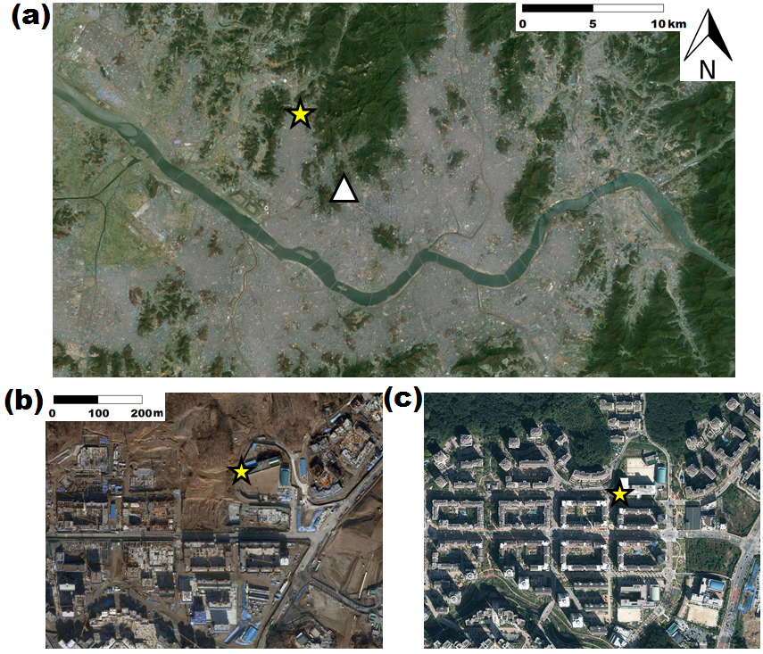

Figure 1. Bird’s eye view images of EunPyeong New Town: (a) Location of EunPyeong New Town site; (b) airborne picture in 2008; (c) airborne picture in 2011. Star and diamond symbols indicate the positions of the flux tower and Seoul synoptic weather observatory (~7.5 km distance away from flux tower), respectively.

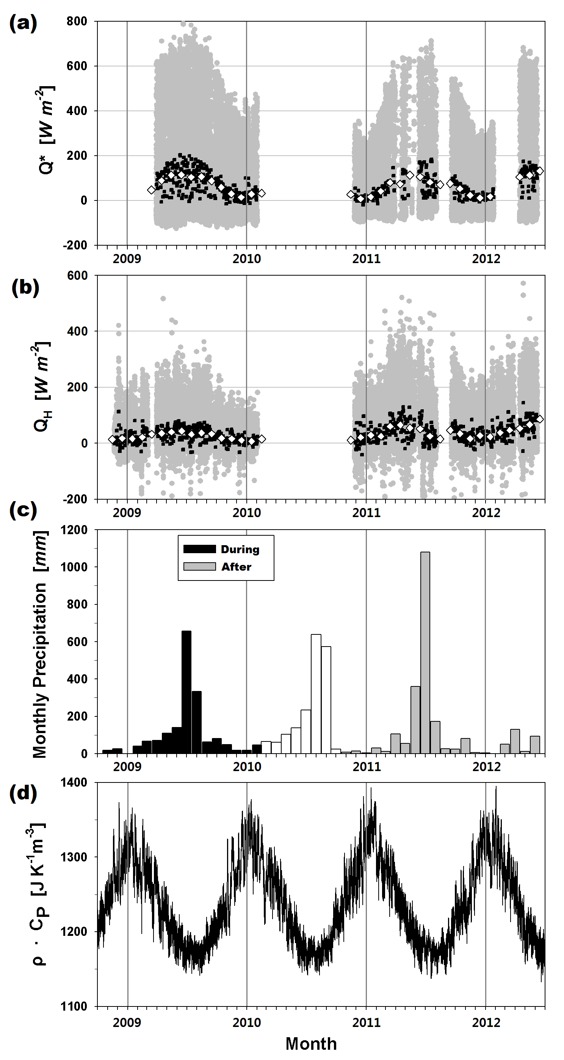

Figure 2. (a) Net all-wave radiation (Q*; W m-2) as calculated at 30-minute averaged intervals (grey dots), daily mean (black squares), and monthly mean (white diamond), (b) sensible heat flux (QH; W m-2), (c) monthly precipitation (mm) before (black), during (white), and after (grey) the EunPyeong New Town redevelopment; and (d) 30 minute averaged ρ·CP values during the study period (November 2008–June 2012), as calculated from observed air temperature, relative humidity, and surface pressure from the Seoul synoptic weather observations (~7.5 km away from flux tower).

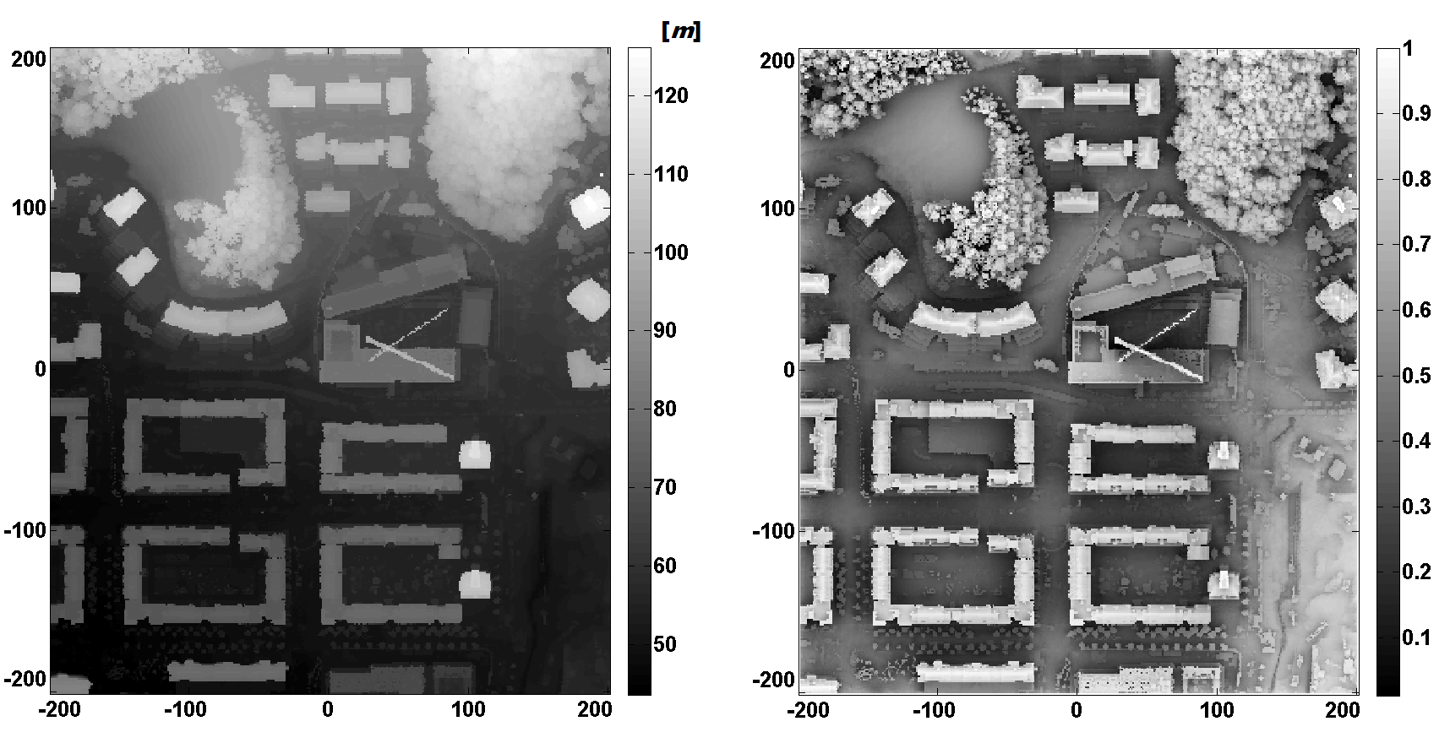

Figure 3. (a) Airborne Light Detection and Ranging (LiDAR) image; and (b) sky view factor (right) of EunPyeong site. Images extend to a radius of 200 m from the flux tower.

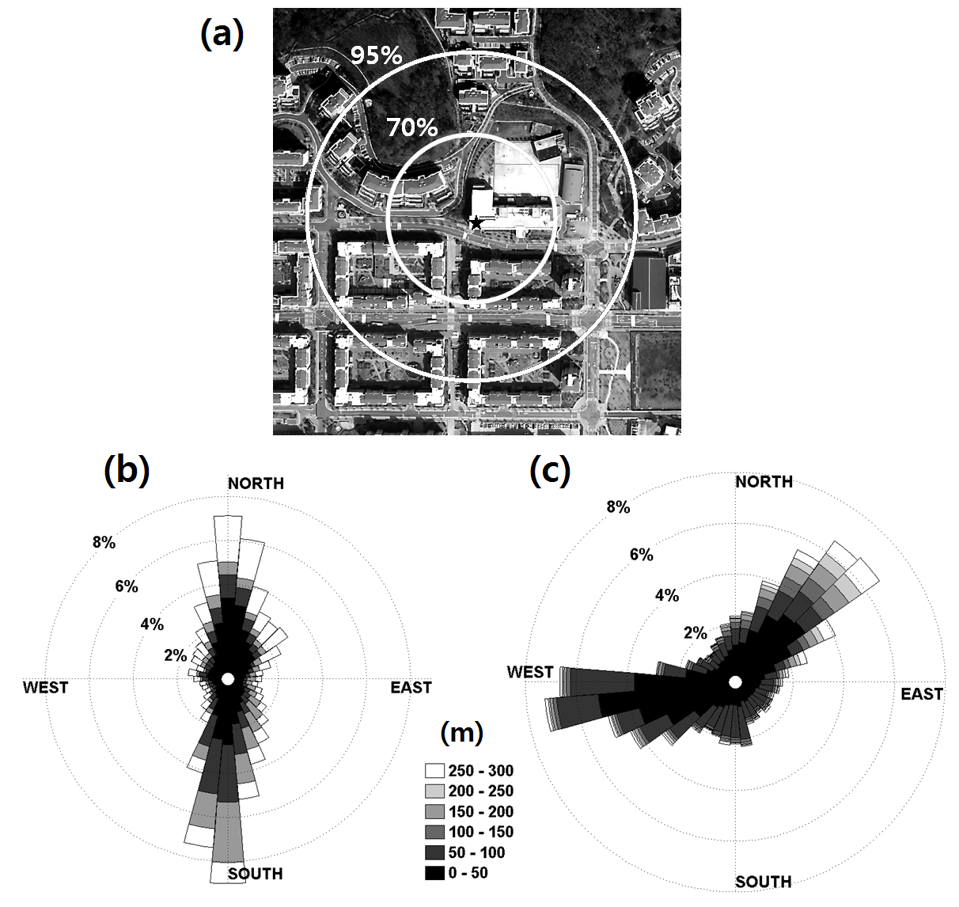

Figure 4. (a) Areas within which the radiative flux footprint contributed up to 70% (~46 m radius), and 95% (~131 m radius); (b) frequency distribution of peak locations for the turbulent flux footprint during (n = 19,131), and (c) after the residential redevelopment (n = 22,610).

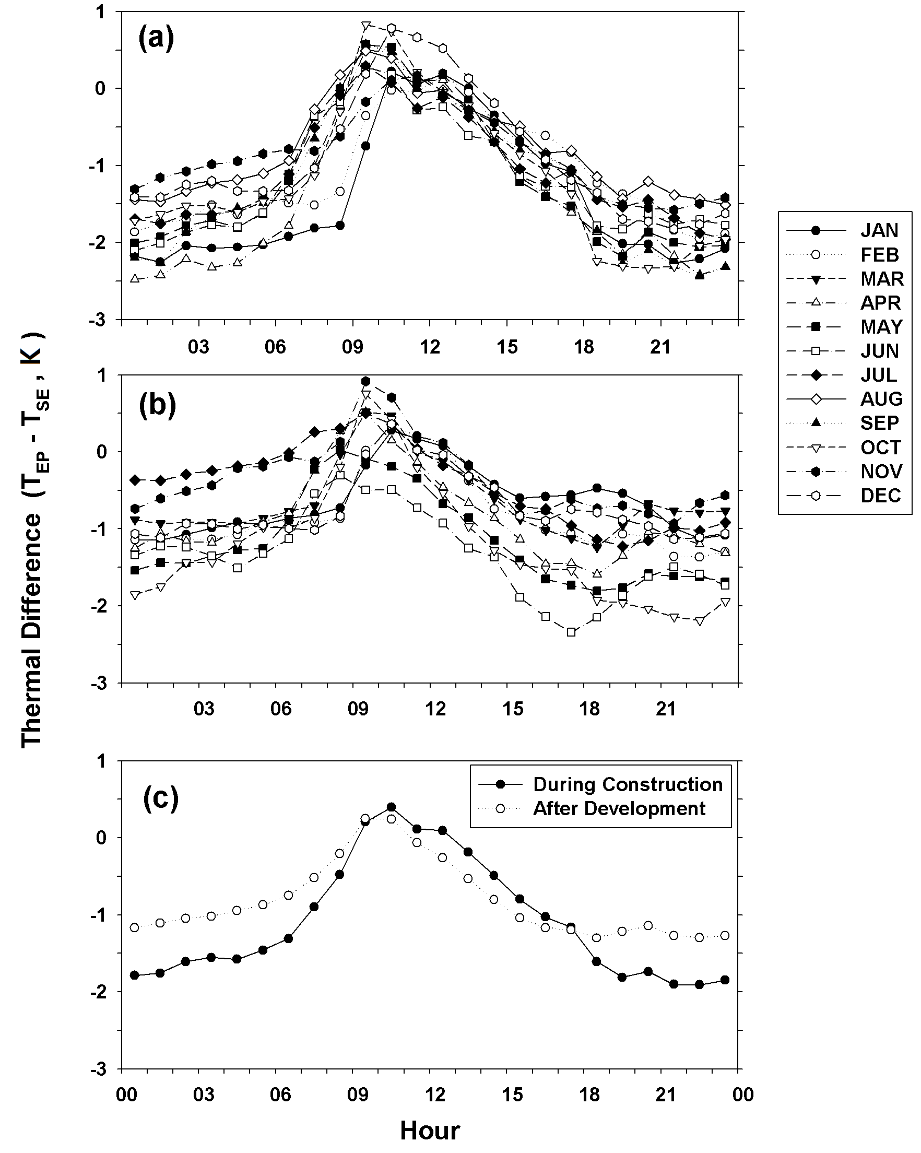

Figure 5. Temporal variations in temperature difference (TEP-TSE; K) across the day (hours) between the EunPyeong site (TEP) and the Seoul synoptic observation station (TSE) for the time periods (a) during construction, and (b) after construction. (c) Total mean diurnal pattern during (black dots) and after (open white circles) construction.

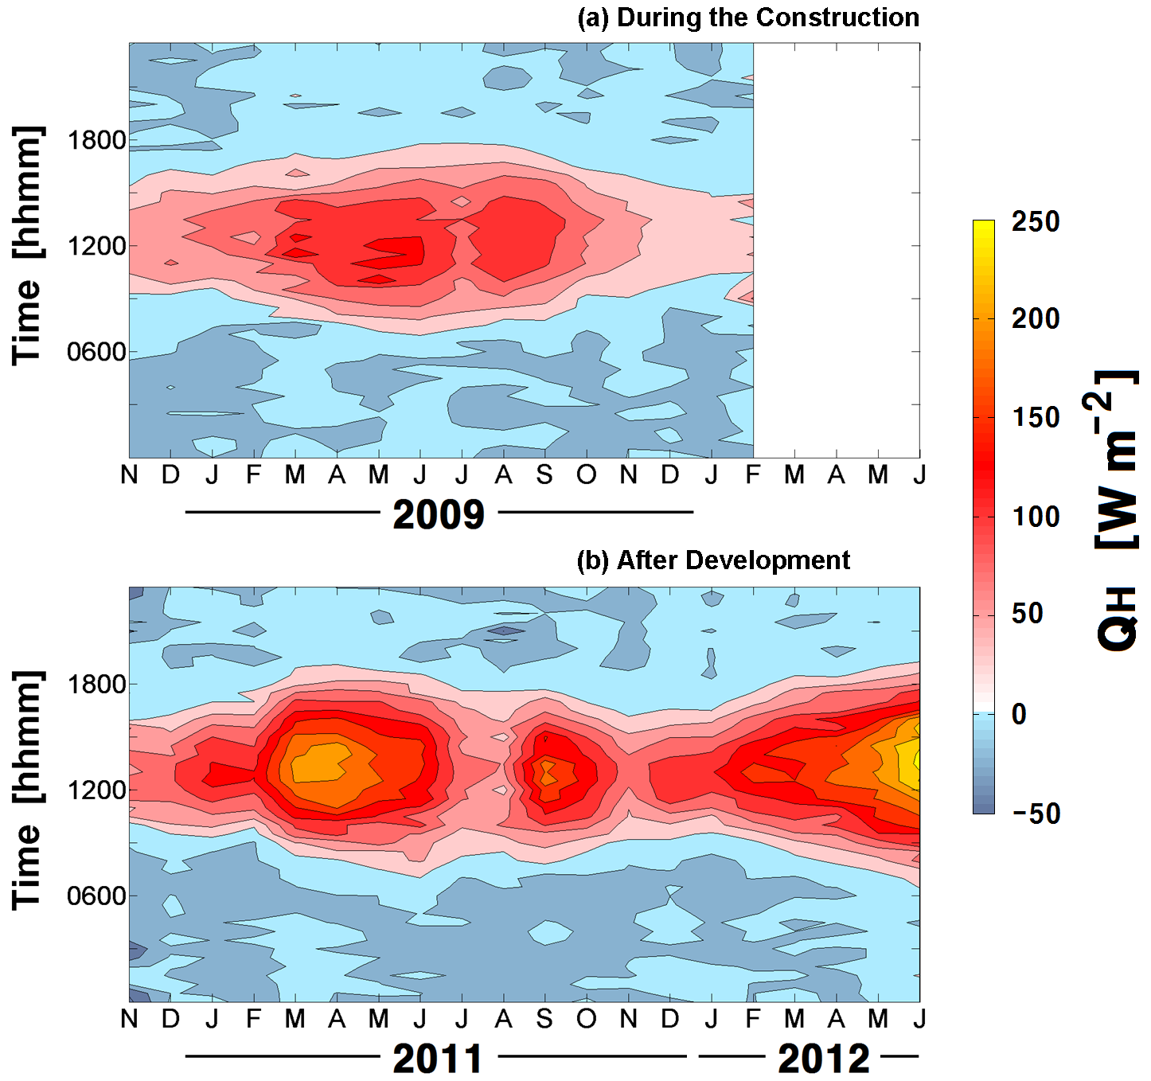

Figure 6. Monthly mean diurnal cycles of sensible heat flux (QH; W m-2) for the period (a) during (November 2008–February 2010), and (b) after the residential redevelopment (November 2010–June 2012).

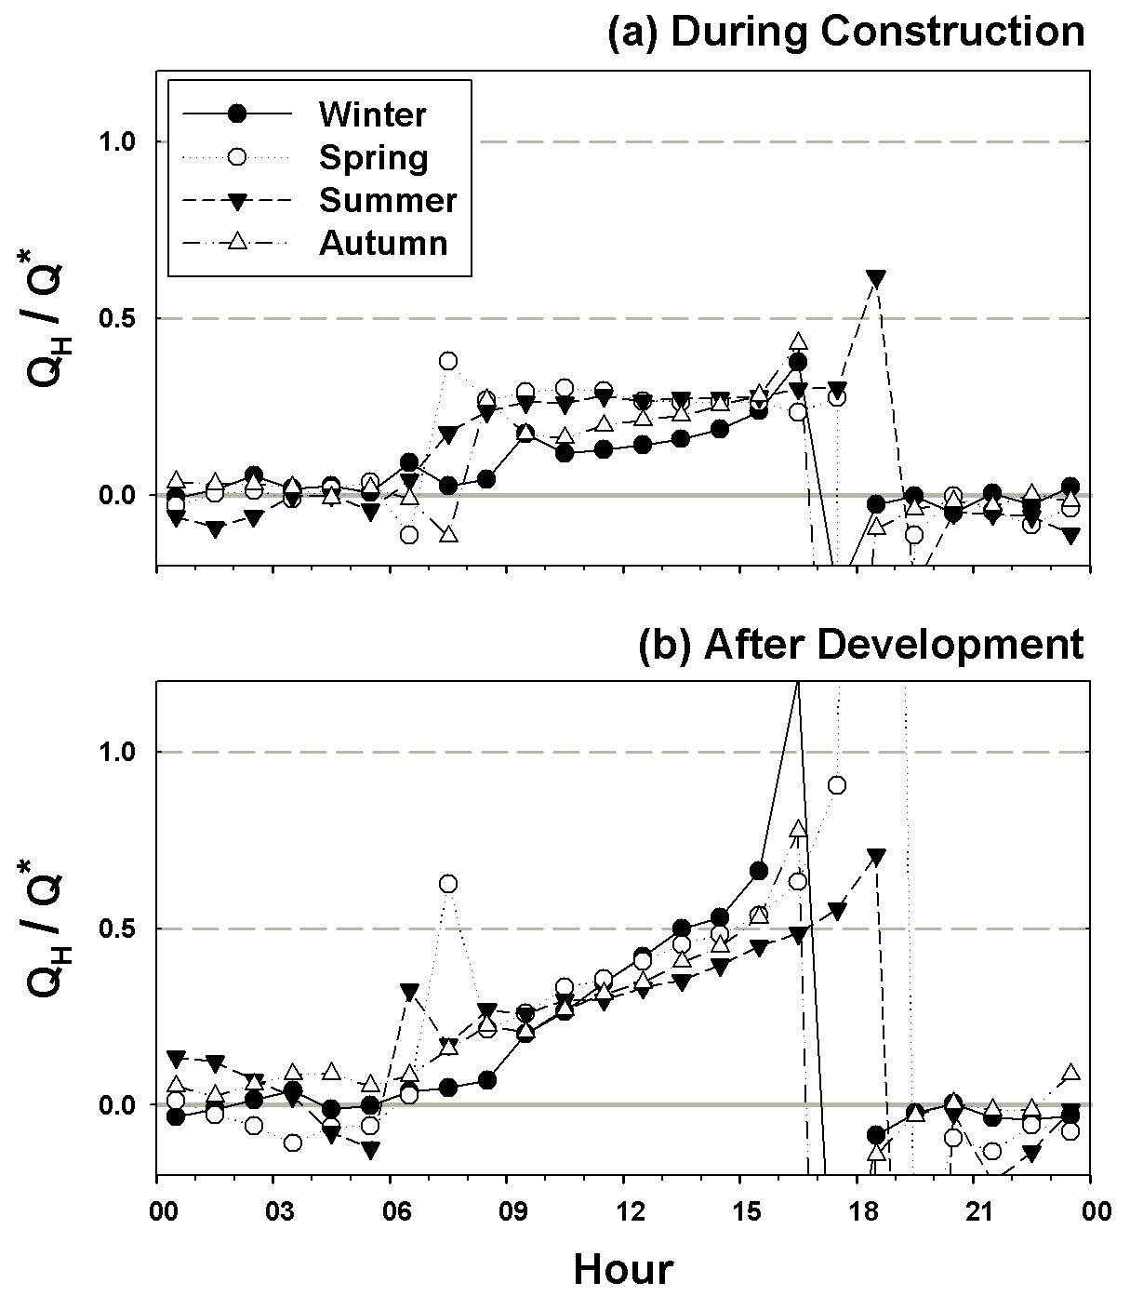

Figure 7. Hourly-averaged diurnal patterns of the ratio between sensible heat flux (QH) and net radiation (Q*) for winter days (black dots), spring days (open white circles), summer days (black triangles), and autumn days (white triangles) for the periods (a) during, and (b) after the residential redevelopment.

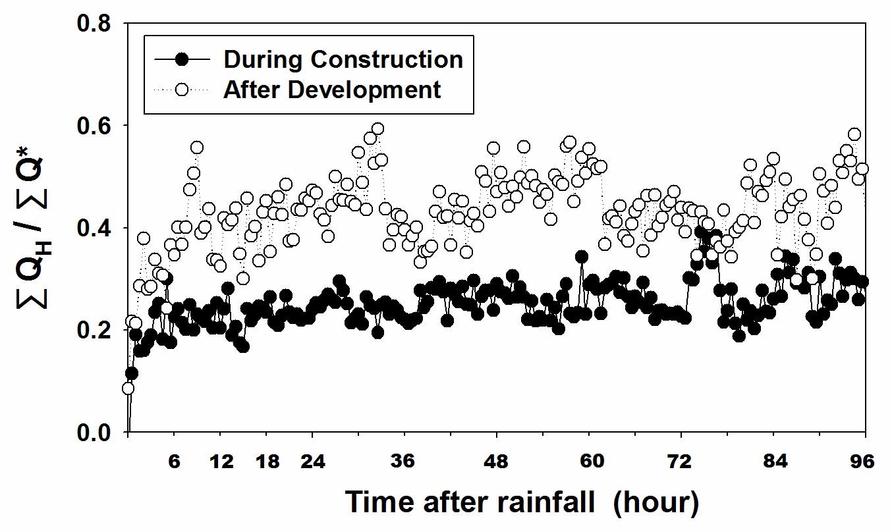

Figure 8. Fraction of sensible heat flux (QH) to net radiation (Q*), after rainfall for the period during (black dots) and after (open white circles) the residential redevelopment.

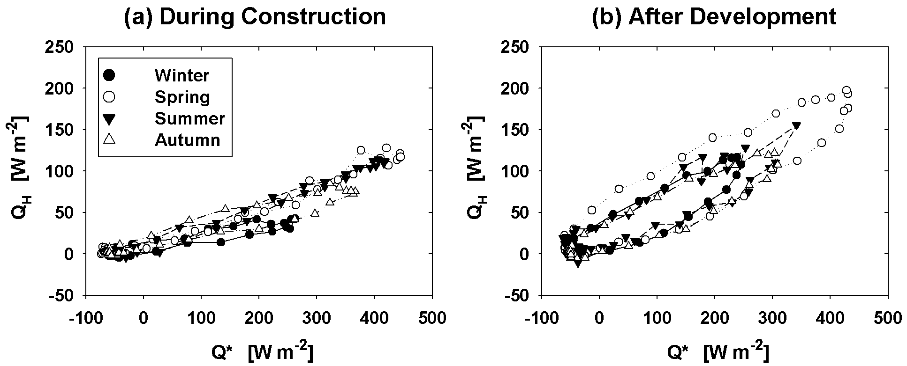

Figure 9. Seasonal mean diurnal hysteresis patterns between sensible heat flux (QH; W m-2) and net radiation (Q*; W m-2) for winter (black dots; December–February), spring (open white circles; March–May), summer (black triangles; June–August), and autumn (white triangles; September–November) for the periods (a) during, and (b) after the residential redevelopment.



Figure A1. Diagram for derivation of heat storage from the hysteresis curve of QH.